### Length of joints

* Finger x,y from thumb rotation
* Finger lengths (thumb to fingers)
* Finger angles

# **1. Organization of the Text for Main Body**

# **1.1 Chapter/Section Headings**

The chapter/section headings are in boldface capital and lowercase letters. Second and third level headings are typed as a new paragraph, and are in boldface capital and lowercase letters. The fourth level heading are part of the succeeding paragraph. You can number your chapter/section/sub-section headings.

## **1.2 Page Numbers**

Please number your pages.

**1.3 Tables**

Tables (refer with: Table 1, Table 2, ...) should be presented as part of the text, but in such a way as to avoid confusion with the text. A descriptive title should be placed above each table. Units in tables should be given in square brackets [meV]. If square brackets are not available, use curly {meV} or standard brackets (meV).

**1.4 Special Signs**

For example , α γ μ Ω () ≥ ± ● Γ {11 0} should always be written in with the fonts Times New Roman, especially also in the figures and tables. Italicize the symbols where required, for example, variables in equations (please refer to equations)

**1.5 Language**

All text, figures and tables must be in English.

**1.6 Figures**

Figures (refer with: Fig. 1, Fig. 2, ...) also should be presented as part of the text, leaving enough space so that the capt­ion will not be confused with the text. The caption should be self-contained and placed *below or beside* the figure.

**1.7 Equations**

Equations (refer with: Eq. 1, Eq. 2, ...) should be indented 5 mm . There should be one line of space above the equation and one line of space below it before the text continues. The equations have to be numbered sequentially, and the number put in parentheses at the right-hand edge of the text. Equations should be punctuated as if they were an ordinary part of the text. Punctuation appears after the equation but before the equation number. The use of Microsoft Equation is allowed.

*c*2 = *a*2 + *b*2.

### 

### Plan

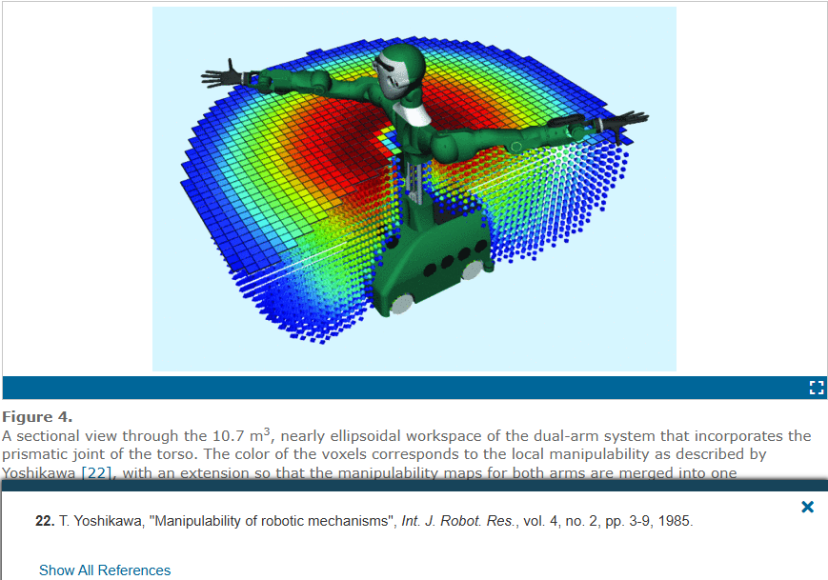

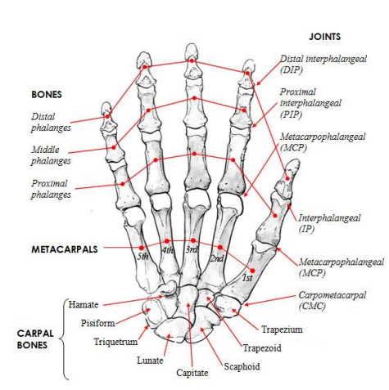

What DOF are needed

By priority (Green is needed)

1. Wrist up and down
2. Rotation in forearm
3. Bending 4 independent fingers
4. 1 DOF for Thumb
5. 2nd DOF for thumb rotating around palm
6. 2nd DOF for bending fingers
7. Abductors
8. 3rd DOF for thumb
9. Final DOF for wrist

Kieran

-Servos modelled

-Find fixtures to buy

-find sensors and encoders and can add to finger

-decide on servos vs DC motors

-Find some tendons and stuff

-fingernails

-tendons could go halfway up

### Brainstorm

* Long solenoids w/
  + Screw w/ small motors
  + Multiple wirings
* High torque under load adjustable mechanism
* Mechanism for spreading all the fingers at once
* Flexible pcb printing for wiring
  + High temperature cables to allow for thinning cables
  + Higher voltage motors for the same reason (24V)
* Flex sensors on back of robotic hands for position sensing
* Expanding air bags between fingers
* One tendon in forearm connected to top finger joint
  + 1 motor in hand connected to bottom joint
  + Spring back fro top two joints
  + Motor to split fingers

65Rpm no load speed aim for fingers

### Lessons from Will Cogley’s hand

* Cables
  + Have play in them so will come out of calibration
    - Could somewhat fix with finger motion sensors (servo sensing almost useless)
  + He used springs to push back
  + He used sheathed cables like on bike cables (tighter is better)
* Can melt in threads to plastic with soldering iron
* https://www.youtube.com/watch?v=l6xqTcLXXC8

### Capacitive sensors

* Can sense force vibration, shear

### Motor company

<https://precisionminidrives.com/product/miniature-dc-gear-motor-3v-6v-12v-model-nfp-ga12-n20-ce>

### Mahonri Meeting

Get the black hand model

### Existing robotic hands

|  | <https://www.youtube.com/watch?v=A7lJxBpecAY&t=301s>  Paper including each important grip type. |
| --- | --- |
|  | Hydraulic, not much info, lot of movement  https://www.youtube.com/watch?v=gd9d_BAXWvg |
|  | Only bending 1-2 deg freedom for fingers, only forearm  <https://www.youtube.com/watch?v=3nnrstBxomk> |
|  | Same sort as above https://www.youtube.com/watch?v=jd79yoccTE8 |
|  | With haptic feedback gloves. Has 2-3 DF for fingers (more for thumb) rest is off the shelf UR5 robot. Also has fancy multipoint pressure sensors on fingers. |
|  | https://robotsguide.com/robots/handarmsystem |
|  |  |
|  |  |

Videos:

<https://www.youtube.com/watch?v=zyl6eoU-3Rg> - Hand Anatamy

<https://www.youtube.com/watch?v=oVy5_3TvmHo> - Tendon Specific Video

| **Key** | |
| --- | --- |
|  | Kieran |
|  | Jack |
|  | Both |
|  | Externally completed |

## Thumb servos

Roughly in order of how good they are:

What we already have (no feedback but otherwise great) 22 x 11 x 20mm:

<https://www.rcjaz.co.nz/futaba-s3114-micro-hightorque-servo-p-90017233.html>

Slightly smaller but has feedback (AUS supplier): 20.0 × 8.3 × 19.3 mm

<https://www.robotgear.com.au/Product.aspx/Details/6778-FEETECH-Sub-Micro-Servo-FS0403-FB-with-Position-Feedback>

Slightly smaller again, does not appear to have mounting points though: 18 * 6.4 * 17.5 mm

<https://www.extremehobbies.co.nz/products/e-flite-35-gram-ds35-digital-super-sub-micro-servo-eflrds35>

<https://www.hangarone.co.nz/shop/radio-gear/servos-gyros/eflite-sub-micro-servos/eflite-sub-micro-servo-ds35-35g-029kg-005-sec?gn=Eflite%20Sub%20Micro%20Servos&gp=5>

Pretty similar to above, slightly different form factor: 20.0 x 8.6 x 17.0

<https://flightrc.co.nz/products/hs-40-ecomomy-nano>

Smallest I've found in AUS/NZ, has no servo horn? 16.3 x 8 x 17mm (4 times less torque than above servo)

<https://www.supercheaphobbies.com.au/store/power-micro-23kg-p-15323.html>

## Small DC motors on fingers

<https://www.aliexpress.us/item/32837968872.html?gatewayAdapt=glo2usa>

12V stall current I measured as 0.22A

## Electronics

* Need to solder resistors to pwm extension boards to change I2c addresses
* 2 x 16 channel mux vs 32 channel mux as they are like 15 times cheaper
* Pressure sensors
  + Not the flexiforce and piezo resistive as they are only good for high forces
* Motors on forearm run with a little bit of force to avoid slack

Priorities

* bowden/pulley cables
* PCB for hand?
  + Might not know optimum resistor values until parts come in, but could just leave blank for it

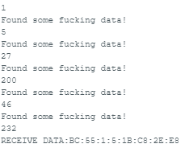

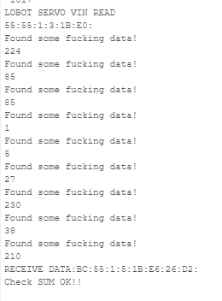

9958

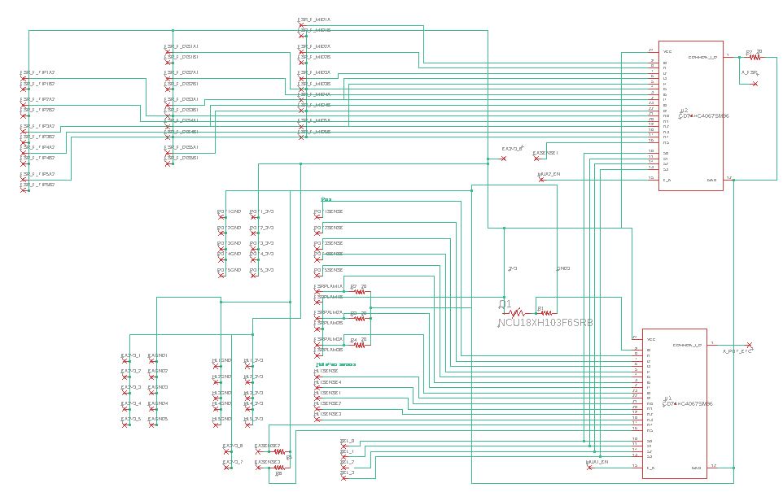

* PCB for controller?
  + Something basic to link all the motor controllers together to save on wiring?
  + That can be extended later?
* Nuts and bolts
* Print parts, get sla gears done

Need to order

Enderv3ke

## PCB

* Min trace width 10mil
  + <https://www.autodesk.com/products/fusion-360/blog/trace-width/#:~:text=For%20most%20manufacturers%2C%20the%20minimum,or%200.254%2D0.3%20mm%20traces>.

TODO

* Figure out why power supply keeps giving error
  + Set the voltage and current (V/C) using pereset button, then set the voltage and current max limits using the ovp/ovc selection, the ovp voltage must be a little higher to account for back emf

Palm sensors

<https://mm.digikey.com/Volume0/opasdata/d220001/medias/docus/695/SEN0296_Web.pdf>

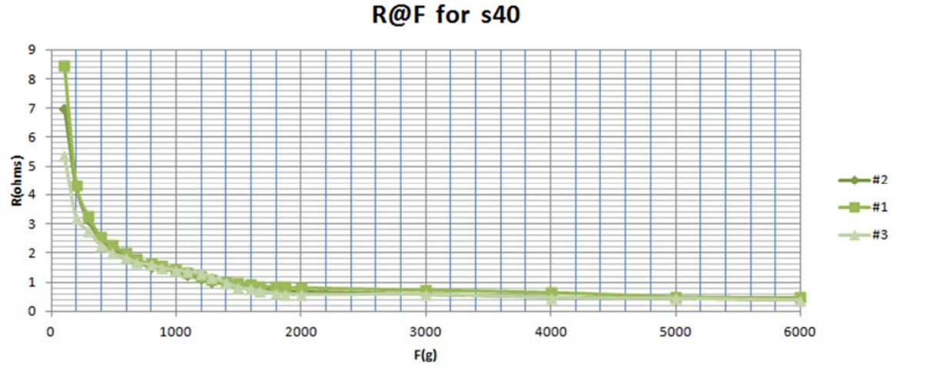

Non linear function of pressure and area, ie same force over like 1/5th the area is like ½ the resistance

**Diagram in datasheet might be in kOhms, its definitely not ohms**

20g over few mm2 area is like 1.5mOhm

640kOhms 500g over a few mm2

2kOhms apply max force from 2 of my fingers

Try 70kohm maybe?

10^((log(2500)+log(2))/2) = 70

**Round sensors (2 on each finger)**

Don't use superglue

* <https://www.sparkfun.com/datasheets/Sensors/Pressure/fsrguide.pdf>
* <https://www.eu.singletact.com/how-to-mount-a-flexible-force-sensor>
* Seamed to work fine when it didnt get in the sensors though (unless in contributed to the delamination of one sensor

Don't trim too much or

* Sensors will delaminate later
* Glue might get inside sensor which will stop it working

Tape over the top might be better as it is non permanent and stops sensors delaminating

* Dabs of glue on the tape?
  + Kinda ugly
  + Reacts a little with the tape…
* Tape doesnt seam to really affect the sensors much

Slight issues on the edge of the finger between the tip and distal fingers as this will actually result in negative force to the tip sensors but I think it should be a positive force picked up by the distal sensor

Bending lowers resistance

6g coin on edge is 56kOhms

Max force on one finger is 100Ohms

280Ohms is probably min res (2ish kilos on my finger)

7.7g over area of little rock is around 100kOhms

Does go higher resistances but its hard to get there

https://www.uneotech.com/uploads/product_download/tw/GHF10-500N%20ENG.pdf

On the order of 1k to 100k

**Long sensors** (1 on each finger)

20g over few mm2 area is like 81kOhm (~30mm cut length)

13k meadsured when benta round finger

10g over few mm2 is 900k or 250k? (~30mm cut length)

Like 750 ohm minimum ~3ish kg pressing with finger)

Cant see any spikes from capacitance with DMM might have to try with oscilloscope

10^((log(800)+log(0.1))/2)

**Resistor value**

Go for 7 OHm resistor for both circle and long

Actually try a bit less maybe 4k

Testing showed a good range and accuracy for both sensors at 3.9k

Aftetr bent around finger maybe 2.2K is better:

10^((log(50)+log(0.1))/2) = 2.2

Can be cut no worries

Est max current is 30*3.3/7000 = 14mA

## Teensy

Install

Works on arduino

<https://www.pjrc.com/teensy/td_download.html>

Hold bootloader button when uploading

Can read internal temperature to check for overheating

Ask chatgpt for code

### Pots

As miniature DC motors were used for the PCP joints (as opposed to servos) joint angle sensing is needed for the PCP joints. The 2 main off the shelf options for this are encoders and potentiometers. Encoders are generally more accurate and less sensitive to vibration so would be the preferred option however they require more space than potentiometers. I instead a potentiometer of size xyz was selected, model that has a range of 330 deg, accuracy, pic of use,

<https://www.bourns.com/docs/Product-Datasheets/3382.pdf> 13 ordered

Need to get slot lined up on 3d printed finger as the 0 point is here

Great resolution!

### Hall sensors

Various options were considered for the MCP joint sensing. One of the most common ways to do angle sensing is of course an off the shelf encoder but these are far too large to fit in the small space requirements of the PIP joint. Smaller than an encoder is a potentiometer based sensor but the 11mm size used in the MCP joint is practically the smallest size available and a potentiometer would need to have a diameter of around 4mm to fit without sticking out from the back of the finger. This leaves custom options and the options with the highest accuracy and smallest form factor appears to be a hall effect sensor coupled with a small neodymium magnet. Some finger designs use a 3 axis hall effect sensor coupled with a diametrically magnitized ring magnet where the magnet rotates but does not translate as in figure and papers. Due to the axis placement at the back of the finger a small enough ring magnet is difficult to acquire if this setup were to be used in our design however, and the 3 axis hall effect sensors require a total of 6? (as in) wires each. Instead we chose a design with a single axis surface mounted hall effect sensor and a magnet placed non-axially. This means that as the finger opens the magnet gets further from the hall effect sensor (as well as rotating), which will decrease the hall effect reading. This creates a nonlinear relationship between hall effect reading and MCP angle and results in a design that has only 3 wires (GND, VCC and Sense), compared to the 6 wires used in the literature. A surface mounted hall effect sensor was used as this is resulted in the best orientation for field sensing and a 5mmx5mm PCB was manufactured to mount this sensor to pictured. The result of this is a very compact sensor setup as shown.

Individual pcbs will be easiest, is possible to solder directly but not easy

Only works when the magnet is facing in one particular direction

Doesn't really work, not sensitive enough/strong enough magnet

Need to order new parts this week

On sign language one said they were designed for measuring angles less than 80 deg, they only have a 3 wire hall effect sensor (like ours)

Problems

* Doesn’t detect magnet greater than like 7mm
  + Does if you line up the pole right
* Rotated magnet close is a lower value than straight on magnet far away
  + This doesn't seem to be an issue for the like 10mm dia 2mm thick magnet
  + Nah this seams ok

Options

* Get the same sensor but the version that is 4 times as sensitive (A1) or twice as sensitive (A2)
* Get Much larger magnets (can kinda test)
* Get 3 axis sensor
  + Maybe with rotating magnet
  + Check what was used for other robot hands
* Try this sensor with rotating magnet
  + Little one next to spring?
* Try this sensor really close
  + Dont think this would work

Order a few different options, at least the sensors that are twice as sensitive and some different magnets but it should work, can increase distance from bend line if the angle distance thing results in multiple positions for each field strength. Not affected by nearby fingers magnets.

Enderv3ke or be is other one V4.3.8.6984

## Wrist servo

One way coms work

2 way doesnt wrok with resistor between tx and rx or with 1 or two transistors

Could try soft serial but might be slow and wasnt working so going to buy a

<https://instantpanel.co.nz/product/ttl-to-rs485-module-serial-port-mcu-automatic-flow-control-module.html?gad_source=1&gclid=CjwKCAjwps-zBhAiEiwALwsVYcQ3uuWqKGybJZxnDYj-MEGMXXgLwpZYJ6RBX0AJkUQCC3_FNGUPqBoCtZgQAvD_BwE>

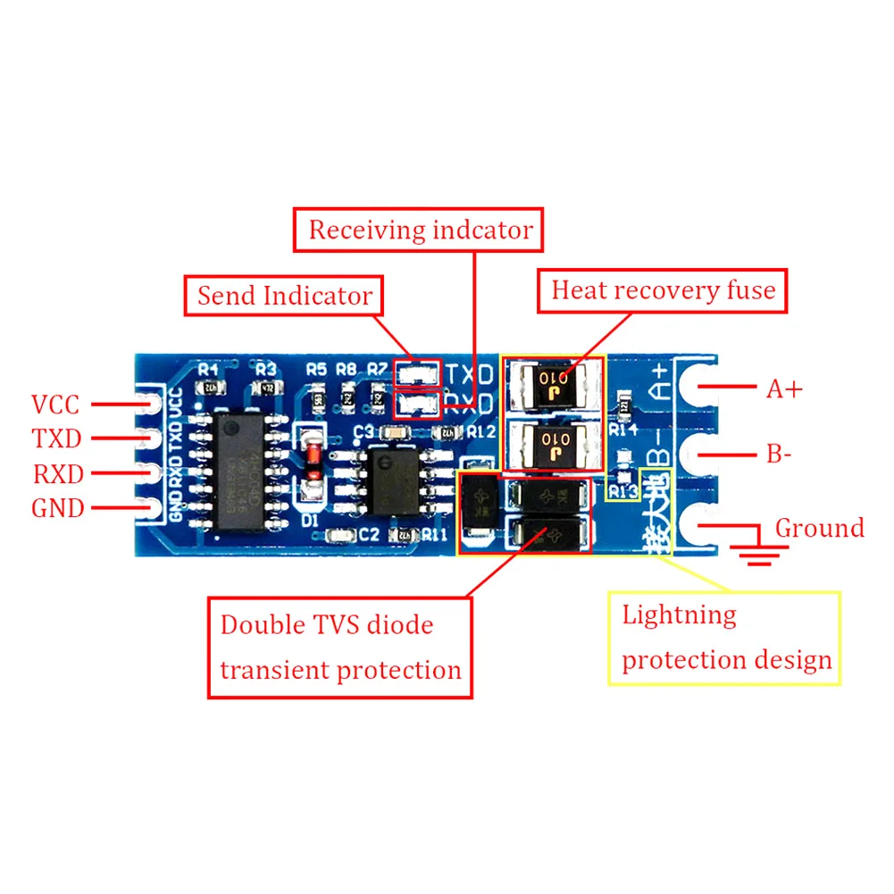

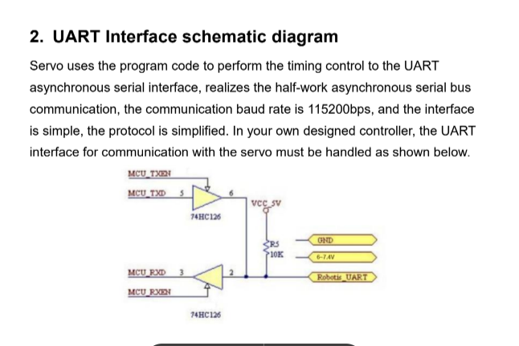

### CAD

Why had the pinky got a bigger fingernail???

Define the Sketches!!!!!

Fix hole all the way through on the pinky proximal phalanx

Go a little bigger on Hall PCB hole

### Springs

Current spring is 0.65-0.7mm steel, it maxes out at like 120 deg (hard to get in) it wont go any further as the action of closing it will permanently deform it to 120 deg. Not enough space to put two. Hard to insert spring if relaxed state is much more than 90 deg.

Bigger 1mm 3 loop torsional springs only have about 60 deg of travel before permanently deforming, ~100 deg needed. These bigger springs also muck up the hall effect sensor calibration

### From lab

10k resistor for thermistor

2.2k resistor for touch fsrs

### To get (inc for second arm)

Ordered

* New PCB
* 12V power supply
* Bolts
* There is some other list somewhere for the second arm
* Round and long sensors…
* 74hc126 (i think it was that one)
* Springs? - digikey???
* Smd resistors
* Another motor controller board

### TODO

* Larger fillets on finger tendons
* Higher tendon holes on fingers
* Middle finger tendon hole needs to be 0.5mm longer on CAD
* Thumb side bit was grinding (for tilt)
* Thumb bottom clearance for gear

When releasing tendons have a much lower maximum rate

Or a maximum slack?

### Testing and report ideas

* Sensor accuracy
  + Put metal objects near hall effect
    - Also affected by metal protractor
  + Pot is probably too good to measure
  + Obviously force sensors
* Sensor refresh rate
* Joint movement accuracies
* Joint speeds
* Joint torques

### SW digital twin

* Sensing angles
  + I think this returns **deg**
  + Use limit angle mates
  + Cant sense if a negative angle so make sure is always positive then add an offset
* Moving joints from API
  + Seems slow? Or at least jerky when adjusting angles directly through mates
    - Also this seems to change a limit angle mate to a standard angle mate which is a slight issue
      * But this doesn't happen if you also set the limits in the API
  + Another option is to adjust in display mode
    - Seams smoother and maybe faster but would have to do manual calculations of offsets
  + When moving joints use **radians**
* Can probably make a bunch of sub assemblies if it is easier to rotate the whole sub assembly
  + YES!!! This will work I think
* Large design review mode??
  + Nah don't think you can move anythin

Left PCB issues (AHHHH!)

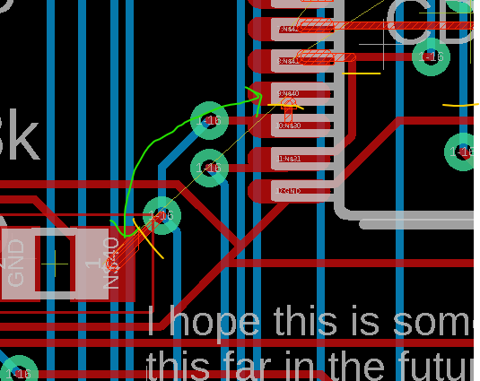

* 4 of the outputs were connected the select inputs so cut a few traces and put in a jumper

Power wiring

Big servos = 8A stall

45kg servos = 3A stall

25kg servos = 2.4-3A Stall

6*8+6*3+10*1.4+12*0.2+0.6 = 35A total

Wires =

Combined control ideas

* Set limit x deg less where x is a linear function fot eh base displacement
* Set power as less
  + Than change back later
* Will close more when tendon power is applied again due to flex in the gears
* Intagral/sum of time that the base is not at position added to tendon position

### Finger control

* When moving base back it is easier to do when the base is in a lower position as the tendon rolls through easier

### Main power sensing

Used aim for 2V = 12V so allows for 450% voltage spike

0.992k and 4.68k = ratio of 5.68

### TODO

* Why is the update frequency 35hz?
  + Reading temp, now its only 17

### Startup sequence

* Don't turn main power on in live control mode
* Don't reset teensy, unplug teensy or upload code when main power is on
* Don't turn main power on again within 5 sec of turning it off